**USE CASE DIAGRAMS FOR FORECASTING SYSTEM**

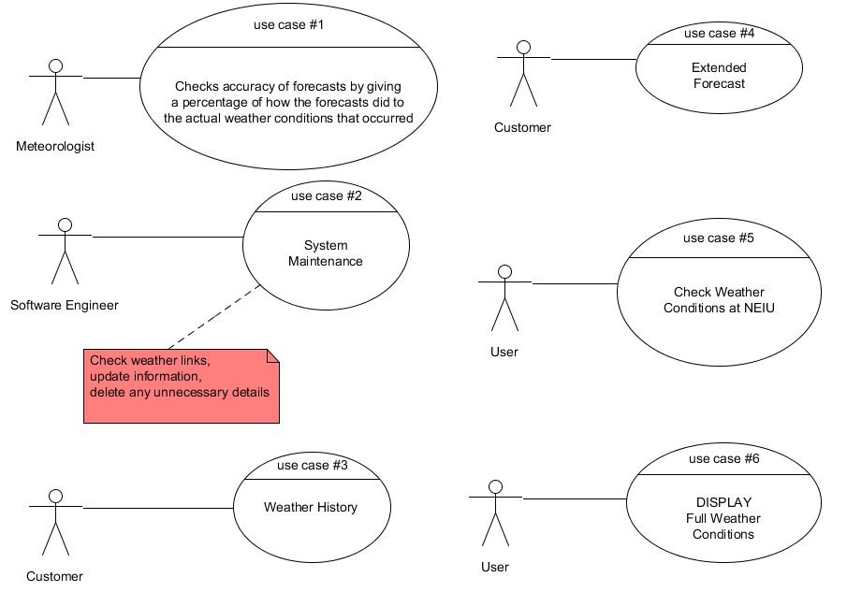

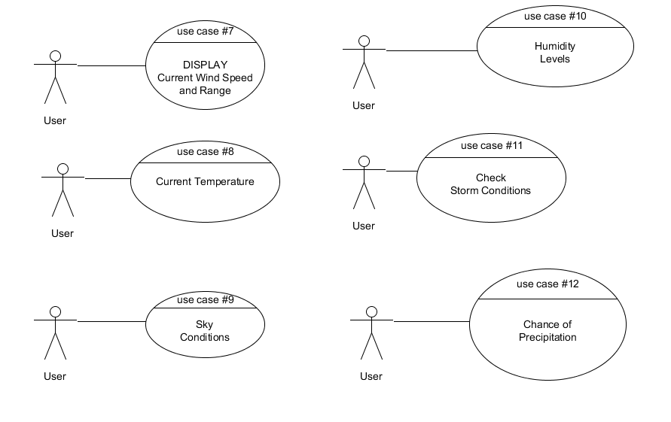

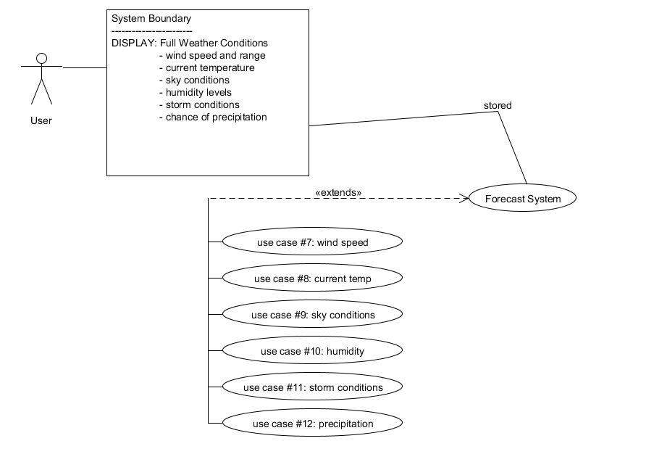

Submitted by:

Dilusha Harischandra

Efren Ulloa

Emmanuel Raguay

Lalitha Vedula

Rob Niesen